Project Design Phase-II
Data Flow Diagram & User Stories

Date | 18 January 2026
Team ID | LTVIP2026TMIDS24884
Project Name | Heart Disease Analysis
Maximum Marks | 4 Marks

Data Flow Diagrams:
A Data Flow Diagram (DFD) is a graphical representation that shows how data moves through a system, including where it comes from, how it is processed, where it is stored, and how it is delivered as output.

Example: (Simplified)

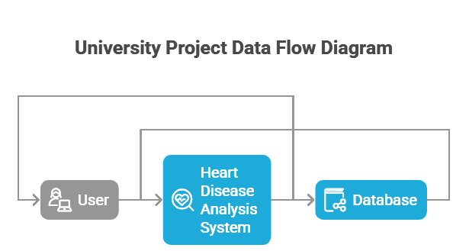

User Stories
Use the below template to list all the user stories for the product.
User Type | Functional Requirement (Epic) | User Story Number | User Story / Task | Acceptance criteria | Priority | Release
Customer (Mobile user) | Registration | USN-1 | As a user, I can register for the application by entering my email, password, and confirming my password. | I can access my account / dashboard | High | Sprint-1
 |  | USN-2 | As a user, I will receive confirmation email once I have registered for the application | Confirmation email is sent and verified | High | Sprint-1
 | Login | USN-3 | As a user, I can log in using email and password | I can access dashboard securely | High | Sprint-1
 | Dashboard Access | USN-4 | As a user, I can register for the application through Gmail |  | Medium | Sprint-1
 | Filter Data | USN-5 | As a user, I can log into the application by entering email & password |  | High | Sprint-1
 | Report Export | USN-6 | As a user, I can download reports | PDF export works correctly | Medium | Sprint-2

